Chapter 19, Problem 86.

Obtain the g parameters for the network in Fig.19.128 using PSpice.

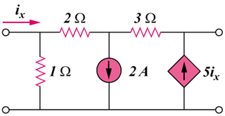

Figure 19.128
For Prob. 19.86.

